OPERATION BARBAROSSA
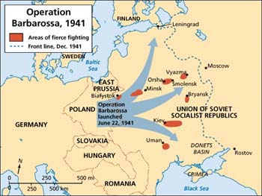
On June 22, 1941, Adolf Hitler launched his armies eastward in a massive invasion of the Soviet Union: three great army groups with over three million German soldiers, 150 divisions, and three thousand tanks smashed across the frontier into Soviet territory. The invasion covered a front from the North Cape to the Black Sea, a distance of two thousand miles. By this point German combat effectiveness had reached its apogee; in training, doctrine, and fighting ability, the forces invading Russia represented the finest army to fight in the twentieth century. Barbarossa was the crucial turning point in World War II, for its failure forced Nazi Germany to fight a two-front war against a coalition possessing immensely superior resources.
The Germans had serious deficiencies. They severely underestimated their opponent; their logistical preparations were grossly inadequate for the campaign; and German industrial preparations for a sustained war had yet to begin. But the greatest mistake that the Germans made was to come as conquerors, not as liberators–they were determined to enslave the Slavic population and exterminate the Jews. Thus, from the beginning, the war in the East became an ideological struggle, waged with a ruthlessness and mercilessness not seen in Europe since the Mongols.
In Barbarossa’s opening month, German armies bit deep into Soviet territory; panzer armies encircled large Soviet forces at Minsk and Smolensk, while armored spearheads reached two-thirds of the distance to Moscow and Leningrad. But already German logistics were unraveling, while a series of Soviet counterattacks stalled the advance. In September the Germans got enough supplies forward to renew their drives; the results were the encirclement battles of Kiev in September and Bryansk-Vyazma in October, each netting 600,000 prisoners.
Moscow seemingly lay open to a German advance, but at this point Russian weather intervened with heavy rains that turned the roads into morasses. The frosts of November solidified the mud, so that the drive could resume. Despite the lateness of the season and the fact that further advances would leave their troops with no winter clothes or supply dumps for the winter, the generals urged Hitler to continue. The Germans struggled to the gates of Moscow where Soviet counterattacks stopped them in early December. In desperate conditions, they conducted a slow retreat as Soviet attacks threatened to envelop much of their forces in a defeat as disastrous as that which befell Napoleon’s Grand Army in 1812. In the end the Soviets overreached, and the Germans restored a semblance of order to the front; the spring thaw in March 1942 brought operations to a halt. But Barbarossa had failed, and Nazi Germany confronted a two-front war that it could not win.
SOURCE: http://www.history.com/topics/world-war-ii/operation-barbarossa

