THE INTERWAR PERIOD (1919-1939)
Each group will research about a country during the interwar period. The final goal of this project is to understand why the different states of the world went to war in 1939. The conclusions will be presented in class on:
- Wednesday 22th and Friday 24th of March (4º D)
- Wednesday 22th and Thursday 23rd of March (4º C)

USA
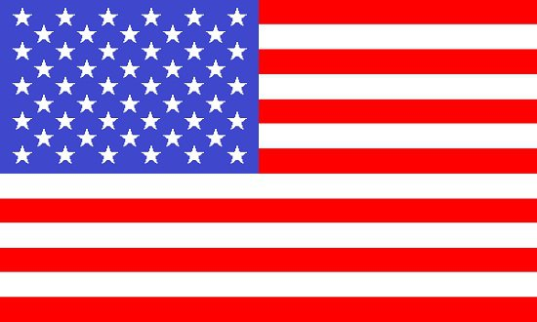
Roaring twenties and the economic crash in 1929
Roosevelt´s New Deal
Political events 1919-1939
Why did US go to WW2?

USSR
End of the Civil War
Lenin´s death and conflict Trotsky-Stalin: the rise of Stalin and the totalitarian State
Soviet socialist economy
Why did USSR go to WW2?

FRANCE
Consequences of the Treaty of Versailles: economic reparations
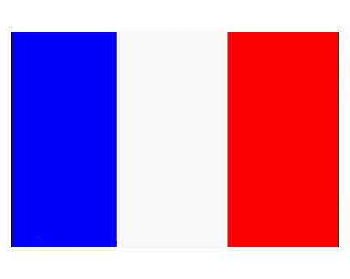
Opposition movements to the Third Republic in the left and right
Consequences of the Great Depression in France
Why did France go to WW2?

GREAT BRITAIN
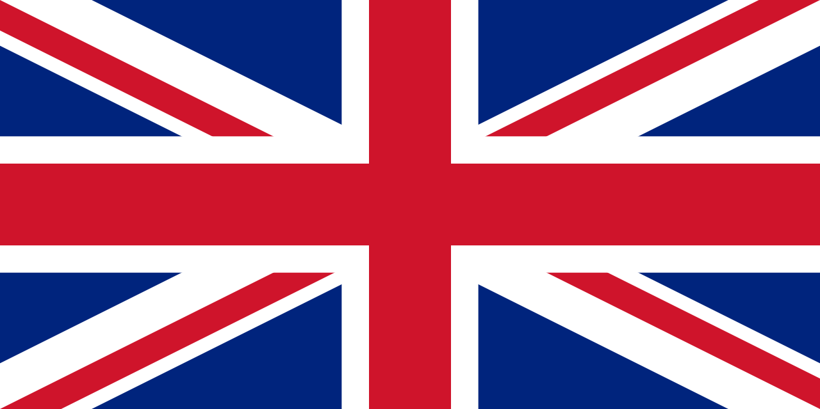
Spread of the welfare state
Economic situation (1919-1939)
British foreign policy
Why did Britain go to WW2?

ITALY
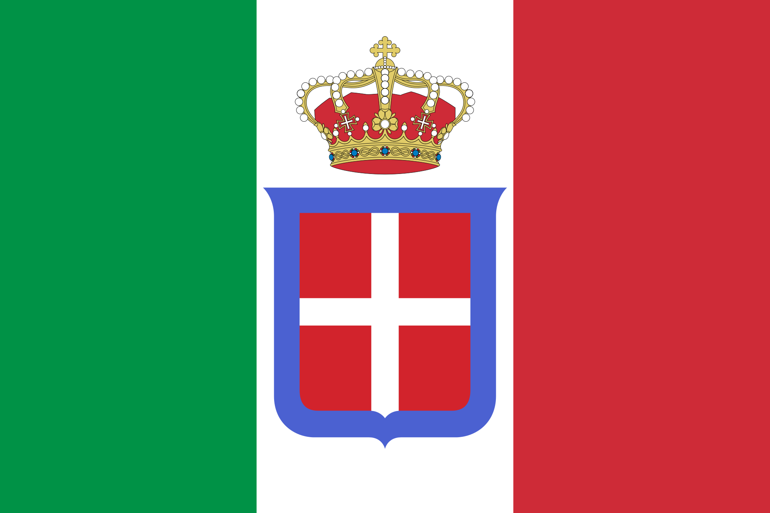
Consequences of the WW1
The rise of Mussolini and fascism
Principles of fascist ideology
Italian economy 1919-1939
Why did Italy go to WW2?

GERMANY
Consequences of the Treaty of Versailles
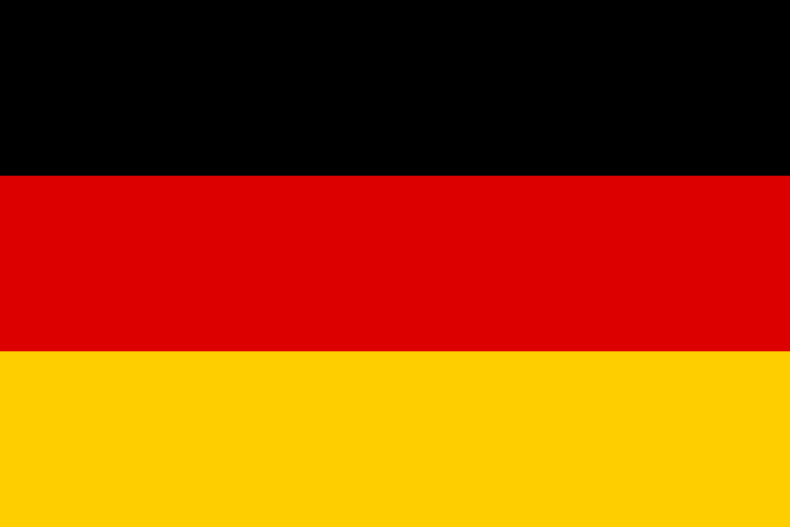
The Weimar Republic
German economy 1919-1939
Rise of Hitler and the Nazi party
Principles of Nazi ideology
Why did Germany go to WW2?

JAPAN
Imperial expansion: Tanaka´s doctrine
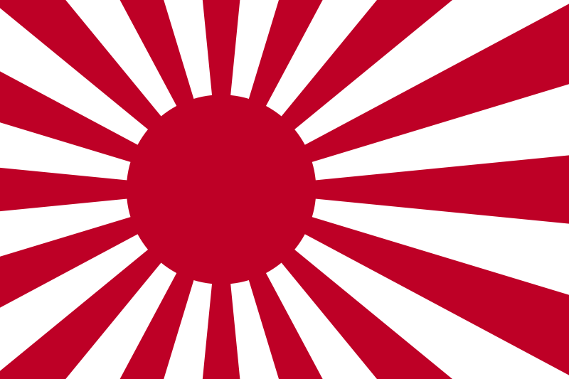
Taisho and Showa periods
Japanese economy 1919-1939
Why did Japan go to WW2?

THE LEAGUE OF NATIONS
Why was necessary a League of Nations? Principles and creation
Main organs and bodies
Causes of its weakness
Why did the League of Nations fail?

