WORKSHEET – THE PIANIST
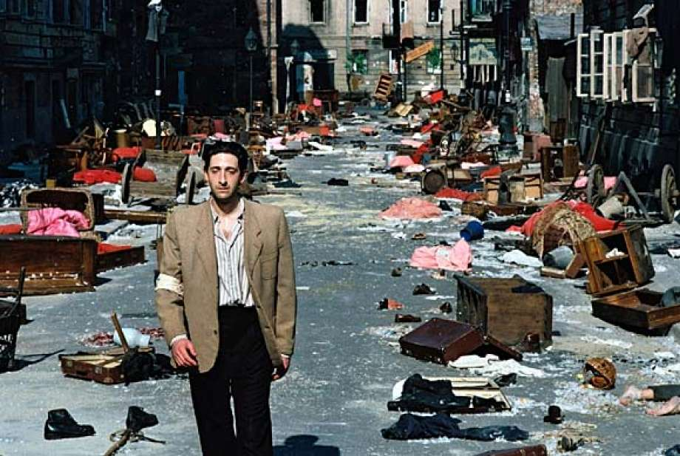
GENERAL REFLECTION:

- Where and when does the movie take place?

- What country invades Poland? Do you know who was ruling that country at that time?

- How do the lives of the Jews change? What was the Warsaw ghetto?

INDIVIDUAL REFLECTION:

- The Jews that got on the trains were transported to Treblinka. Search information about that place. How many people were slaughtered there?

- Did you like the movie? Write a critical review of at least 6 lines (remember to say what you liked and didn´t like and why, what you learned, how you felt while watching the movie…)

- Do you think something like that could ever happen again?

